
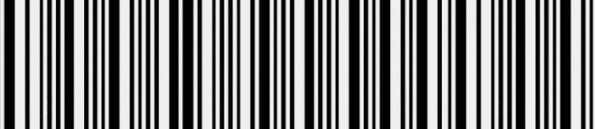
0000
Return Slip

Complete the return form

Put the product into another box along with the return slip

Send the package by your local post


Sender
Name/Surname/Company:
Invoice date: Invoice number:
Payment method:

Return address
FC-Moto GmbH & Co. KG
c/o Brettschneider GmbH
Retourenabteilung
Philipsstraße 8
52068 Aachen
Please note the following:
- Please put the products in a box
- For parcels which need to go through the customs, it is mandatory that the content can be identified. Therefore, please enclose a copy of the invoice with the package and attach another copy outside of the package with the remark that it is a return. Parcels, which are marked with a lower value, no invoice or no reason for the return, will automatically be send back to the despatcher
- You have the possibility to choose between DTU (unpaid) or DTP (paid) when you send your parcel. With DTU, you only pay the pure return costs. DTP involves both the shipping costs as well as the costs for the customs duties. If you have chosen DTU, the incurred clearance costs will be charged to the customer (see our general terms and conditions
Return/swap an item
Please enter the correct number, stating the reason for your return into the field
*01 defective | 02 don’t like it | 03 size is too big | 04 size is too small | 05 badly made | 06 wrong item delivered
07 not delivered on time | 08 does not match the description

Amount | Item number | Description |  | Reason * | Refund | Exchange

Description in case of defect

Refund
You will always receive the refund via the same payment method you used to make the original purchase in our shop.
We kindly ask for your understanding that a refund can take up to 14 days.

